
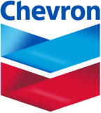
JOINT OPERATIONS
SAUDI ARABIAN CHEVRON INC. - KUWAIT GULF OIL COMPANY (K.G.O.C.)

New Supplier Registration Form

Date | July 30, 2026
Company Name
Commercial Registration Number
Commercial Registration Expiry
SAC or KGOC Registration Number
SAC or KGOC Registration Expiry
Type of Business
List of Manufacture Agencies
Address Data
City
PO Box
Telephone Number
Fax
Company Email Address
Working hours
Authorized Person of online Transactions
Name
Job Title
Email Address
Mobile
Please sing and Stamp the from and attach it to online application

Company Signature

Name:
Title:

